# Assessment File

**INDEX**

1. Abstract
2. Types of Online Appointment Software
3. Hardware/ Software Requirements
4. Software Requirement Specifications
5. Schedule Matrix
6. Modules
7. Output Screens

***Abstract :-*** Appointment scheduling software or meeting scheduling tools allows businesses and professionals to manage appointments and bookings. This type of software is also known as appointment booking software and online booking software. PMS System belongs to the class of application software intended for storage and management of information of contracts, project, and tasks. The systems are used to control data entry to contracts, task orders, projects, tasks.

Customer appointment management scheduling software falls under two categories: desktop applications and web-based systems (also known as software as a service or cloud-based systems).

**Desktop Based**

Desktop applications are programs that are usually licensed and installed on end-user maintained computer hardware. Such programs are generally very robust in terms of features and reporting, and can often be customized, but one downside is that desktop applications often do not have an online portal for staff or customer access.[clarification needed] As well, installed applications may require ongoing maintenance, support, and upgrading by the end-user.

**Web-Based**

Web-based systems are usually provided by a third-party service provider that offers appointment scheduling tools and features as a hosted software solution, usually provided via a web browser. One common benefit is that customers are provided the option of booking their own appointments. This facilitates appointment scheduling over the web as customers can access their usual professionals' schedules at their convenience 24/7 and make appointments online through the Internet. This type of software does not require any update since the updates are directly implemented to the cloud.

**Mobile App Based**

With the advent of smartphone driven era, appointment booking apps are the most convenient to use. User can browse through the app to look for the most suitable service provider (keeping both quality and budget in consideration) and can request an appointment for the same. Some mobile applications use the same app for both customers and providers while some have different apps for both. Beauty[1], Salon[2], Health[3] and Wellness[4] industries have been using such apps with success.

**Schedule Matrix of 20 Days**

|  |  |
| --- | --- |
| Study | 02 |
| Requirement Gathering | 06 |
| Designing | 02 |
| Development | 8 |
| Testing and Implementation | 4 |

***Output Screens***

**1. Register Page: -** This is Register page in which You can register new user

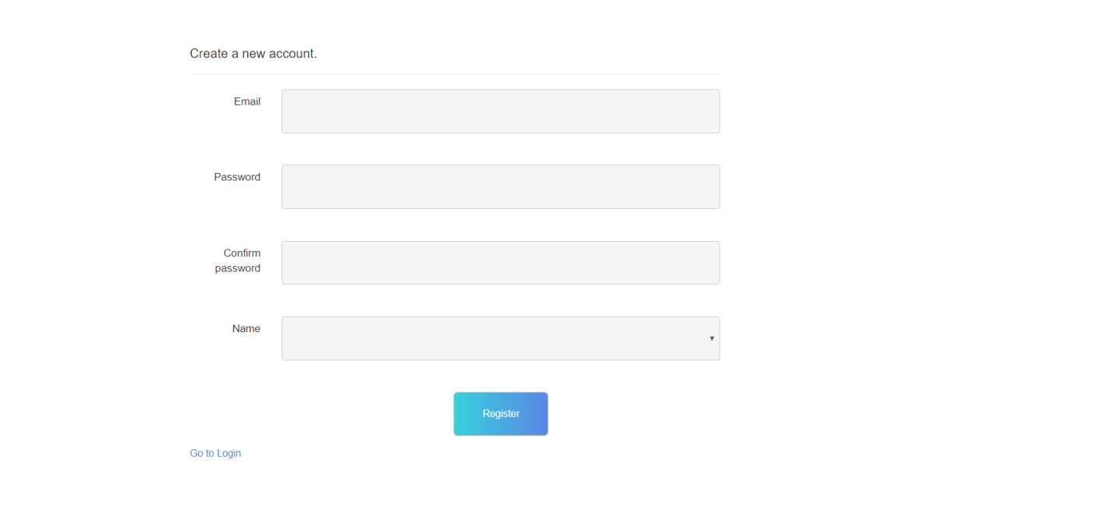

**2. Login Page: -** This is Login page of our website. In this page I can login as a Admin and As a Manager.

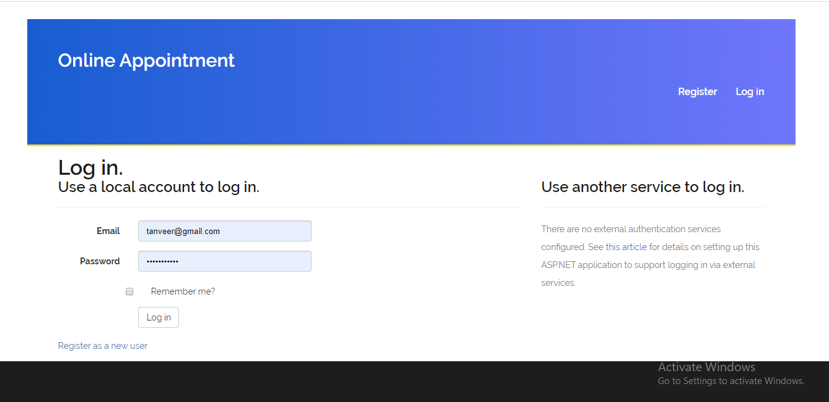

**3. Admin Login**: When admin logins then he can access the all modules of website. Which are shown in the picture.

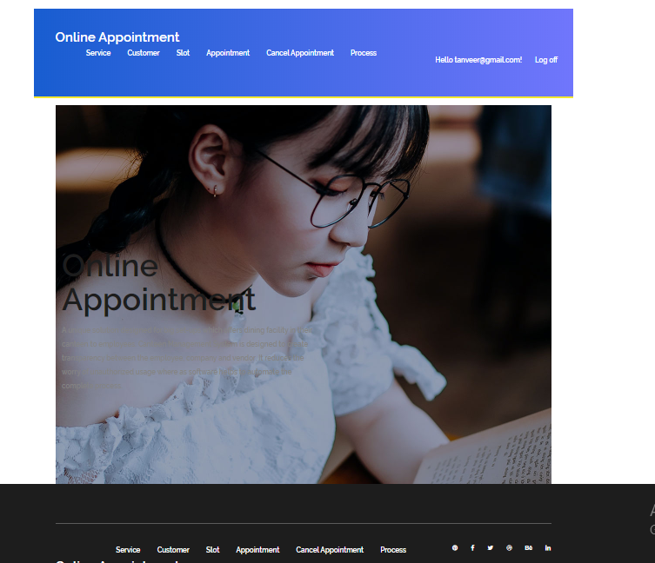

**4. Service: -**  Here I can show the service in my website. And clicking on the create new link I can create the service. Edit and delete service are also available here.

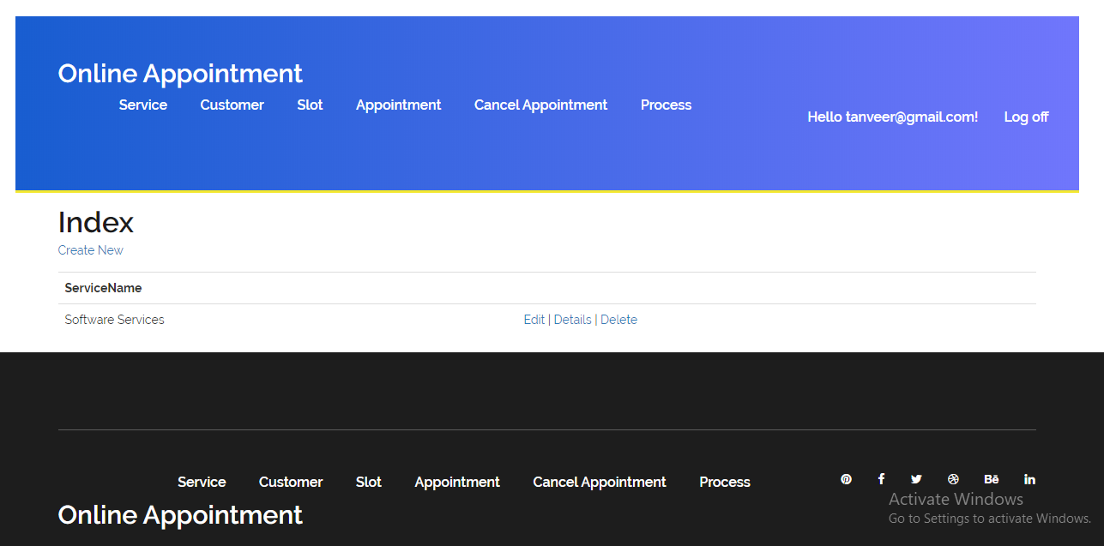

**5. Customer: -**  Here I can show the customer in my website. And clicking on the create new link I can create the customer. Edit and delete customer are also available here.

